Nama : Erlangga Rizal Mahendra

NIM : 2440101704

Mo_6

1. Display TreatmentTypeName, TreatmentName, and Price for every treatment which name contains ‘hair’ or start with ‘nail’ word and has price below 100000.

(**join**, **like**)

USE OOVEO_Salon

SELECT

MsTreatmentType.TreatmentTypeName,

MsTreatment.TreatmentName,

MsTreatment.Price

FROM

MsTreatment

JOIN

MsTreatmentType

ON

MsTreatment.TreatmentTypeId = MsTreatmentType.TreatmentTypeId

WHERE

(

MsTreatmentType.TreatmentTypeName LIKE '%hair%'

or

MsTreatmentType.TreatmentTypeName LIKE 'nail%'

)

AND

MsTreatment.Price < 100000

1. Display StaffName and StaffEmail (obtained from the first character of staff’s name in lowercase format and followed with last word of staff’s name and ‘@oosalon.com’ word) for every staff who handle transaction on Thursday.The duplicated data must be displayed only once.

(**distinct**, **lower**, **left**, **reverse**, **left**, **charindex**, **join**, **datename**, **weekday**, **like)**

USE OOVEO_Salon

SELECT

DISTINCT

MsStaff.StaffName, --- Data yang sama tidak akan ditampilkan

LOWER(LEFT(MsStaff.StaffName,1)) +

LOWER(RIGHT(MsStaff.StaffName,CHARINDEX(' ',REVERSE(MsStaff.StaffName)) - 1)) +

'@oosalon.com' AS 'staff email'

FROM

MsStaff

JOIN

HeaderSalonServices

ON

HeaderSalonServices.StaffId = MsStaff.StaffId

WHERE

DATENAME(WEEKDAY,HeaderSalonServices.TransactionDate) = 'Thursday'

1. Display New Transaction ID (obtained by replacing ‘TR’ in TransactionID with ‘Trans’), Old Transaction ID (obtained from TransactionId), TransactionDate, StaffName, and CustomerName for every transaction which happened 2 days before 24th December 2012.

(**replace**, **join**, **datediff**, **day**)

USE OOVEO_Salon

SELECT

REPLACE(HeaderSalonServices.TransactionId,'TR','Trans') AS 'New Transaction ID',

HeaderSalonServices.TransactionId AS 'Old Transaction ID',

HeaderSalonServices.TransactionDate,

MsStaff.StaffName,

MsCustomer.CustomerName

FROM

HeaderSalonServices

JOIN

MsStaff

ON

MsStaff.StaffId = HeaderSalonServices.StaffId

JOIN

MsCustomer

ON

MsCustomer.CustomerId = HeaderSalonServices.CustomerId

WHERE

DATEDIFF(DAY,HeaderSalonServices.TransactionDate, '2012/12/24') = 2

1. Display New Transaction Date (obtained by adding 5 days to TransactionDate), Old Transaction Date (obtained from TransactionDate), and CustomerName for every transaction which didn’t happen on day 20th.

(**dateadd**, **day**, **join**, **datepart**)

USE OOVEO_Salon

SELECT

DATEADD(DAY,5,HeaderSalonServices.TransactionDate) AS 'New Transaction ID',

HeaderSalonServices.TransactionDate AS 'Old Transaction ID',

MsCustomer.CustomerName

FROM

HeaderSalonServices

JOIN

MsCustomer

ON

MsCustomer.CustomerId = HeaderSalonServices.CustomerId

WHERE

DATEPART(DAY, HeaderSalonServices.TransactionDate) !=20

1. Display Day (obtained from the day transaction happened), CustomerName, and TreatmentName for every Customer who was handled by female staff that has position name begin with ‘TOP’ word. Then order the data based on CustomerName in ascending format.

(**datename**, **weekday**, **join**, **in**, **like**, **order by**)

USE OOVEO_Salon

SELECT

DATENAME(WEEKDAY, HeaderSalonServices.TransactionDate) AS 'Day',

MsCustomer.CustomerName,

MsTreatment.TreatmentName

FROM

HeaderSalonServices

JOIN

MsCustomer

ON

MsCustomer.CustomerId = HeaderSalonServices.CustomerId

JOIN

DetailSalonServices

ON

DetailSalonServices.TransactionId = HeaderSalonServices.TransactionId

JOIN

MsTreatment

ON

MsTreatment.TreatmentId = DetailSalonServices.TreatmentId

JOIN

MsStaff

ON

MsStaff.StaffId = HeaderSalonServices.StaffId

WHERE

MsStaff.StaffGender IN ('Female')

AND

MsStaff.StaffPosition LIKE 'top%'

ORDER BY

MsCustomer.CustomerName ASC

1. Display the first data of CustomerId, CustomerName, TransactionId, Total Treatment (obtained from the total number of treatment). Then sort the data based on Total Treatment in descending format.

(**top**, **count**, **join**, **group by**, **order by**)

USE OOVEO_Salon

SELECT

TOP

1 MsCustomer.CustomerId,

MsCustomer.CustomerName,

HeaderSalonServices.TransactionId,

COUNT(DetailSalonServices.TreatmentId) AS 'Total Treatment'

FROM

MsCustomer

JOIN

HeaderSalonServices

ON

HeaderSalonServices.CustomerId = MsCustomer.CustomerId

JOIN

DetailSalonServices

ON

DetailSalonServices.TransactionId = HeaderSalonServices.TransactionId

GROUP BY

MsCustomer.CustomerId,MsCustomer.CustomerName,HeaderSalonServices.TransactionId

ORDER BY

'Total treatment' DESC

1. Display CustomerId, TransactionId, CustomerName, and Total Price (obtained from total amount of price) for every transaction with total price is higher than the average value of treatment price from every transaction. Then sort the data based on Total Price in descending format.

(**sum**, **join**, **alias subquery**,**avg**, **group by**, **having**, **order by**)

USE OOVEO_Salon

SELECT

MsCustomer.CustomerId,

MsCustomer.CustomerName,

HeaderSalonServices.TransactionId,

SUM(MsTreatment.Price) AS 'Total Price'

FROM

MsCustomer

JOIN

HeaderSalonServices

ON

HeaderSalonServices.CustomerId = MsCustomer.CustomerId

JOIN

DetailSalonServices

ON

DetailSalonServices.TransactionId = HeaderSalonServices.TransactionId

JOIN

MsTreatment

ON

MsTreatment.TreatmentId = DetailSalonServices.TreatmentId

GROUP BY

MsCustomer.CustomerId,

MsCustomer.CustomerName,

HeaderSalonServices.TransactionId

HAVING

SUM(MsTreatment.Price) > (SELECT SUM(av.Hasil) FROM (SELECT AVG(MsTreatment.Price) AS Hasil) AS av)

ORDER BY

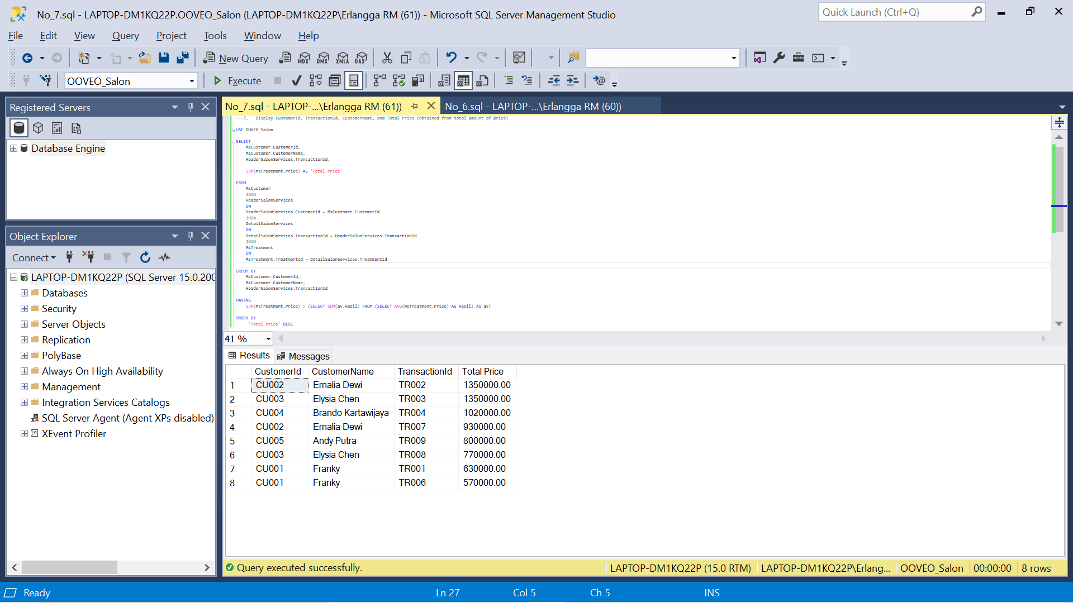 'Total Price' DESC

7.1 Menghitung total masing-masing baris

USE OOVEO_Salon

SELECT

SUM(MsTreatment.Price), TransactionId

FROM

MsTreatment

JOIN

DetailSalonServices

ON

DetailSalonServices.TreatmentId = MsTreatment.TreatmentId

GROUP BY

DetailSalonServices.TransactionId

7.2 Menghitung rata-rata

USE OOVEO_Salon

SELECT

AVG(Average.Total)

FROM

(SELECT SUM(Price) AS Total FROM DetailSalonServices

JOIN

MsTreatment

ON

DetailSalonServices.TreatmentId = MsTreatment.TreatmentId

GROUP BY

TransactionId) AS Average

1. Display Name (obtained by adding ‘Mr. ’ in front of StaffName), StaffPosition, and StaffSalary for every male staff. The **combine** it with Name (obtained by adding ‘Ms. ’ in front of StaffName), StaffPosition, and StaffSalary for every female staff. Then sort the data based on Name and StaffPosition in ascending format.

(**union**, **order by**)

USE OOVEO_Salon

SELECT

'Mr. ' + MsStaff.StaffName AS 'Name',

MsStaff.StaffPosition AS 'StaffPosition',

MsStaff.StaffSalary

FROM

MsStaff

WHERE

MsStaff.StaffGender IN ('Male')

UNION

SELECT

'Ms. ' + MsStaff.StaffName AS 'Name',

MsStaff.StaffPosition,

MsStaff.StaffSalary

FROM

MsStaff

WHERE

MsStaff.StaffGender IN ('Female')

ORDER BY

'Name','StaffPosition' asc

1. Display TreatmentName, Price (obtained by adding ‘Rp. ’ in front of Price), and Status as ‘Maximum Price’ for every Treatment which price is the highest treatment’s price. Then **combine** it with TreatmentName, Price (obtained by adding ‘Rp. ’ in front of Price), and Status as ‘Minimum Price’ for every Treatment which price is the lowest treatment’s price.

(**cast**, **max**, **alias** **subquery**, **union**, **min**)

USE OOVEO_Salon

SELECT

MsTreatment.TreatmentName,

'Rp. ' + CAST(MsTreatment.Price AS VARCHAR) AS Price,

'Minimum Price' AS 'Status'

FROM

MsTreatment

WHERE

Price = (SELECT MIN(Price) FROM MsTreatment)

UNION

SELECT

MsTreatment.TreatmentName,

'Rp. '+ CAST(MsTreatment.Price AS VARCHAR) AS Price,

'Maximum Price' AS 'Status'

FROM

MsTreatment

WHERE

Price = (SELECT MAX(Price) FROM MsTreatment)

1. Display Longest Name of Staff and Customer (obtained from CustomerName), Length of Name (obtained from length of customer’s name), Status as ‘Customer’ for every customer who has the longest name. Then **combine** it with Longest Name of Staff and Customer (obtained from StaffName), Length of Name (obtained from length of staff’s name), Status as ‘Staff’ for every staff who has the longest name

(**len**, **max**, **alias subquery**, **union**)

USE OOVEO_Salon

SELECT

MsCustomer.CustomerName AS 'Longest Name Of Staff and Customer',

LEN(MsCustomer.CustomerName) AS 'Length Of Name',

'Customer' AS 'Status'

FROM

MsCustomer

WHERE

LEN(MsCustomer.CustomerName) = (SELECT MAX(LEN(MsCustomer.CustomerName))

FROM

MsCustomer)

UNION

SELECT

MsStaff.StaffName AS 'Longest Name Of Staff and Customer',

LEN(MsStaff.StaffName) AS 'Length Of Name',

'Staff' As 'Status'

FROM

MsStaff

WHERE

LEN(MsStaff.StaffName) = (SELECT MAX(LEN(MsCustomer.CustomerName))

FROM

MsCustomer)